05/08/2019

Conflict of Mineral Statement

As of many of our supplier and customers we are disturbed by reports within the Democratic Republic of Congo (DRC) regarding forced labour & other human rights. These mining operations include these metals:

- Gold
- Tantalum
- Tungsten
- Tin
- Colbalt

A.M.E only purchase from manufacturers within Europe and do not knowingly procure specified metals that originate from facilities in the 'Conflict Region'. We will continually monitor our supply
chain to ensure this policy is strictly adhered to.

Yours sincerely

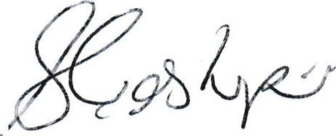

Suzanne Easthope
Company Secretary

